**KIBABII UNIVERSITY**

**DIGITAL AND ANALOG COMMUNICATION**

**Name: Raha Habib  
Admission No:COM/0501/21**

**CAT 1**

1.Using suitable diagrams and equations explain how AM is achieved. (Given carrier signal is Wc MHz and information signal is Wm Khz where both waves are sinusoidal)

**Amplitude modulation** is a process by which the wave signal is transmitted by modulating the amplitude of the signal. It is often called AM and is commonly used in transmitting a piece of information through a radio carrier wave. Amplitude modulation is mostly used in the form of electronic communication. The modulating signal is the information signal that we want to transmit.

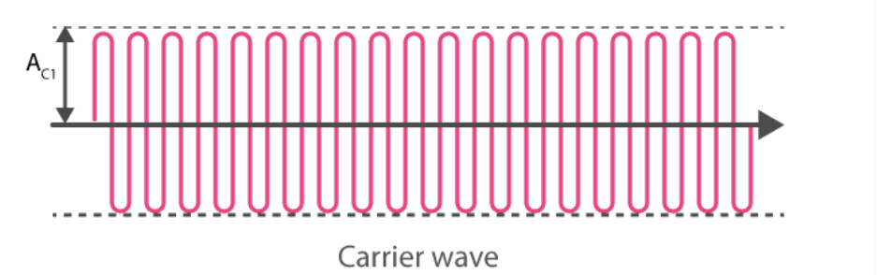

The amplitude and frequency of a carrier wave remain constant. Generally, it will be high frequency, and it will be a sine or cosine wave of electronic signal; it can be represented as

C(t) = Ac sin wct

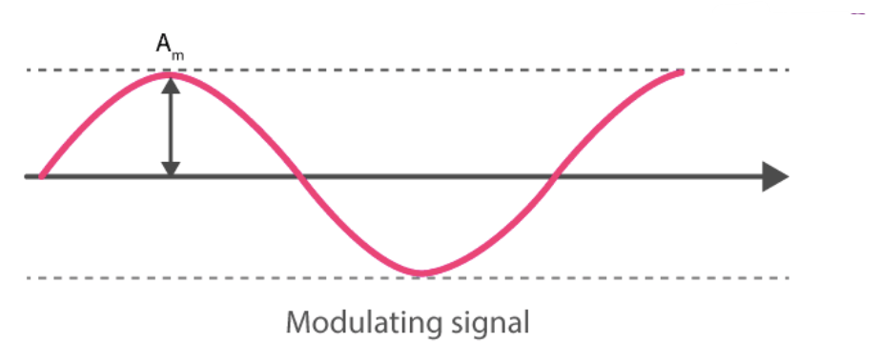

The modulating signal is nothing but the input signal (electronic signal), which has to be transmitted. It is also a sine or cosine wave; it can be represented as

### Frequencies of Amplitude Modulated Wave

There are three frequencies in amplitude modulated wave – f1, f2 and f3– corresponding to ωc, ωc + ωm and ωc – ωm, respectively.

ω1 = ωc → it is corresponding f1 = fc

ω2 = ωc + ωm → it is corresponding f2 = fc + fm

ω3 = ωc – ωm → it is corresponding f3 = fc – fm

Where fc → Carrier wave frequency

fc + fm → Upper side band frequency

fc – fm → Lower side band frequency

fm → Modulating signal frequency

In general, fc > > fm

**Bandwidth: (BW)**It is the difference between the highest and lowest frequencies of the signal.

BW = Upper sideband frequency – Lower sideband frequency (fc – fm)

Or

BW=fmax−fmin

BW = fc + fm – fc + fm = 2 fm

BW = 2fm = Twice the frequency of the modulating signal

**Modulation Index**

It is the ratio of the amplitude of the modulating signal to the amplitude of the carrier wave.



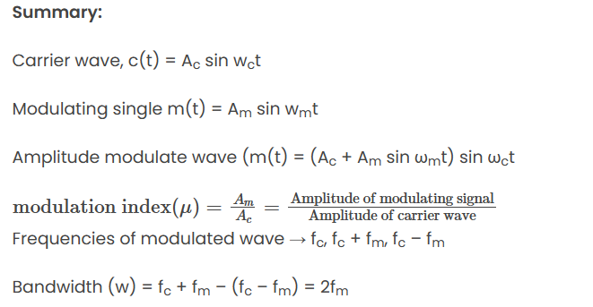

2. State the equation for AM modulation index

The equation for AM modulation index is given by:

Modulation index (m) = (Amplitude of modulating signal) / (Amplitude of carrier signal)



3. State the equation for FM modulation index

The equation for FM modulation index is given by:  
Modulation index (m) = (Frequency deviation) / (Modulating frequency)

4. Sketch a labeled diagram of the frequency spectrum of an AM wave

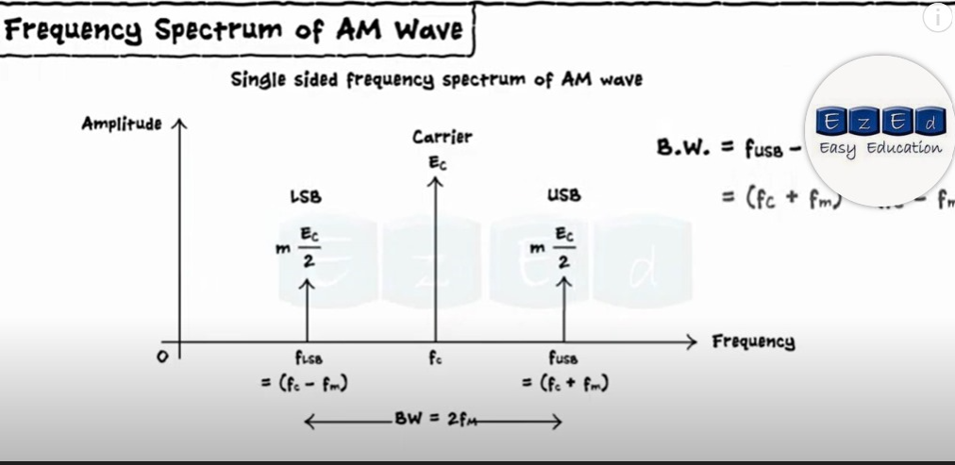

**5.Draw a block diagram of** CDMA spread spectrum and explain how the system operates.

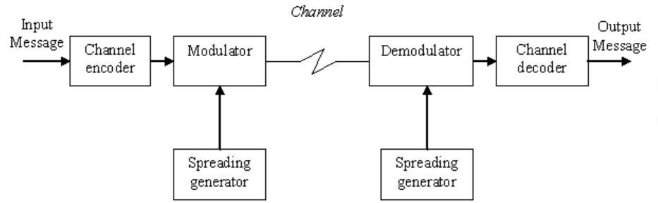

1. **Digital Data**: CDMA systems transmit digital data. This data is typically in the form of binary digits (0s and 1s) representing voice, text, or other types of information.
2. **Pseudo-Random Codes**: Each user in a CDMA system is assigned a unique pseudo-random code, often referred to as a spreading code or a Walsh code. These codes are designed to look random but are deterministic and known to both the transmitter and the receiver.
3. **Spreading**: Before transmission, the user's digital data is "spread" by multiplying it with the assigned pseudo-random code. This process expands the bandwidth of the signal, spreading the energy of the signal across a wider frequency band.
4. **Transmission**: The spread data from multiple users can be transmitted simultaneously over the same frequency band. Each user's spread signal appears as noise to other users, but it can be uniquely identified and separated at the receiver by using the corresponding pseudo-random code.
5. **Receiver Processing**: At the receiver, the incoming signal is despread by multiplying it with the same pseudo-random code used at the transmitter. This process narrows down the signal to its original bandwidth, effectively extracting the user's information.
6. **Decoding**: The despread signal is then decoded to retrieve the original digital data. The decoding process involves combining the received signal with the pseudo-random code to reconstruct the original data.

6.Differentiate between GSM technology and CDMA Technology.

The differences between [GSM](https://www.geeksforgeeks.org/gsm-in-wireless-communication/) and [CDMA](https://www.geeksforgeeks.org/cdma-full-form/) are as follows:

| **Serial No.** | **GSM** | **CDMA** |
| --- | --- | --- |
| 1. Full form global | Global System for Mobile communication. | Code Division Multiple Access. |
| 2. Technology used | [FDMA](https://www.geeksforgeeks.org/frequency-division-multiple-access-fdma-techniques/)(Frequency Division Multiple Access) and [TDMA](https://www.geeksforgeeks.org/difference-between-fdma-and-tdma/#:~:text=TDMA%20is%20channelization%20protocol%20in,location%20of%20the%20time%20slot.) (Time Division Multiple Access). | CDMA(Code Division Multiple Access). |
| 3. Availability | GSM is globally widely used and available. | CDMA is available in fewer countries and carriers. |
| 4. Data speed rate | 42Mbps in HSPA (3G). | 3.6Mbps in CDMA. |
| 5.Features | GSM supports transmitting data and voice both at once. | CDMA does not support this feature. |
| 6. Customer Information | Stored in a SIM card. | Stored in a headset or phone. |
| 7. Encryption | GSM does not provide built-in encryption is available. | CDMA provides built-in encryption. |
| 8. Secure | GSM offers less secure communication. | CDMS offers secure communication. |
| 9. Roaming | GSM enables worldwide roaming. | CDMA enables limited roaming. |
| 10. Signal Detection | GSM signals can be detected since they are focused in a narrow bandwidth. | CDMA transmissions are difficult to detect. |
| 11. SIM Card | There is always a requirement of SIM card for a GSM device to function. | There are no such requirements for CDMA phones. |
| 12. Flexibility | When a SIM on a phone stops working, we can use another SIM rather than purchasing a new phone. | When a CDMA on a phone ceases operating, we must purchase a new phone. |
| 13. Type of Spectrum | GSM technology operates on a wedge spectrum known as carrier. | CDMA technology is based on spread spectrum technology. |
| 14. MIMO (Multiple Input Multiple Output) method | GSM follows 2*2 MIMO. | LTE adheres to 8*8, 4*4 MIMO and also supports cooperative MIMO and multi-user MIMO. |

7. Explain about Voice Over Internet Protocol.   
Voice Over Internet Protocol (VoIP) is a technology that allows users to make voice calls over the internet instead of using traditional phone lines. This is achieved by converting analog voice signals into digital data packets that can be transmitted over the internet.

VoIP offers several advantages over traditional phone systems, including lower costs, greater flexibility, and the ability to integrate with other digital communication tools. It also allows for features such as video calling, conference calling, and voicemail to email transcription.

One of the key benefits of VoIP is cost savings, as it typically offers lower calling rates and eliminates the need for separate phone lines. Additionally, VoIP systems are often easier to set up and maintain, as they can be managed through a web-based interface.

VoIP can be used with a variety of devices, including computers, smartphones, and specialized VoIP phones. It can also be integrated with other digital communication tools, such as email and instant messaging, to create a unified communication platform.

Overall, VoIP offers a cost-effective and flexible alternative to traditional phone systems, making it an increasingly popular choice for businesses and individuals.

### 8.Describe 3 types of noise in telecommunication and electronics External Source

This noise is produced by the external sources which may occur in the medium or channel of communication, usually. This noise cannot be completely eliminated. The best way is to avoid the noise from affecting the signal.

### Examples

Most common examples of this type of noise are −

* Atmospheric noise (due to irregularities in the atmosphere).
* Extra-terrestrial noise, such as solar noise and cosmic noise.
* Industrial noise.

### Internal Source

This noise is produced by the receiver components while functioning. The components in the circuits, due to continuous functioning, may produce few types of noise. This noise is quantifiable. A proper receiver design may lower the effect of this internal noise.

### Examples

Most common examples of this type of noise are −

* Thermal agitation noise (Johnson noise or Electrical noise).
* Shot noise (due to the random movement of electrons and holes).
* Transit-time noise (during transition).
* Miscellaneous noise is another type of noise which includes flicker, resistance effect and mixer generated noise, etc.

## **Signal to Noise Ratio**

**Signal-to-Noise Ratio (SNR)** is the **ratio of the signal power to the noise power**. The higher the value of SNR, the greater will be the quality of the received output.

## **Figure of Merit**

The ratio of **output SNR to the input SNR** can be termed as the **Figure of merit (F)**. It is denoted by **F**.

Thermal Noise   
This thermal noise is present in all transmission media and on all communication equipment. Caused by hot electrons in the conductor (thermal agitation of the electrons), so they cannot be removed/eliminated. Thermal noise has a uniform energy distribution in the frequency spectrum and has a normal (Gaussian) level distribution. Thermal noise is a determining factor for the lower limit of receiver system sensitivity. Thermal noise is not very influential for voice transmission, but it will greatly affect data communication. In data communication, noise impulses can make the received signal defect, so that the data or information carried can change its meaning. Thermal noise can be approximated by white noise which has a uniform power spectral density in the frequency spectrum. All equipment and transmission media have a share in the generation of thermal noise when the temperature is above 0o (degrees Kelvin). Ways to reduce thermal noise include:  
 (1) Narrow the bandwidth  
 (2) Reduce the number of resistive elements  
 (3) Reduce the temperature of the electron component   
(4) Keep the transmission media away from noise sources   
(5) Giving the jacket on the cable

Noise Intermodulation  
 When signals with different frequencies together use the same transmission medium, resulting in signals at a frequency which is the addition or multiplication of the two original frequencies. For example, signals with frequencies f1 and f2 will interfere with signals with frequencies f1 and f2, this is due to the non-linearity of the transmitter, receiver or transmission system. Intermodulation noise usually arises as a result of intermodulation symptoms. When we pass two signals each with a frequency, for example f1 and f2 through a medium or non-linear device, spurious frequencies originating from signal harmonic frequencies will be generated. located within or outside the desired working frequency band. This intermodulation can be formed from the harmonic frequency of a signal.

9. Baseband in the transmission of communications signals means only one path is available to send and receive digital signals between devices. Describe the various ways in which baseband is used.

a. Information is carried in digital form on a single signal channel that isn’t multiplexed, it uses transmission medium e.g (Copper twisted-pair wires).  
b. With Multiplexing, a transmission channel derives additional paths over a baseband channel.  
c. A baseband signal transmits data streams as analog signals using modulation technology.  
d. With any frequency band on which information is superimposed, baseband can be used whether or not the band is multiplexed and information is send on subbands.  
-In addition to this, it’s assumed that the carrier frequency band used isn’t shifted to a different frequency band but remains at its original place in the electromagnetic spectrum.

10.In order to transmit [computer](https://www.britannica.com/technology/computer) data and other digitized information over a communications channel, an analog carrier wave can be modulated to reflect the binary nature of the digital baseband signal. Explain ASK, FSK and PSK digital modulation techniques

## [Amplitude-shift keying](https://www.britannica.com/technology/amplitude-shift-keying)

If amplitude is the only [parameter](https://www.merriam-webster.com/dictionary/parameter) of the carrier wave to be altered by the information signal, the modulating method is called amplitude-shift keying (ASK). ASK can be considered a digital version of analog amplitude modulation. In its simplest form, a burst of radio frequency is transmitted only when a binary 1 appears and is stopped when a 0 appears. In another variation, the 0 and 1 are represented in the modulated signal by a shift between two preselected amplitudes.

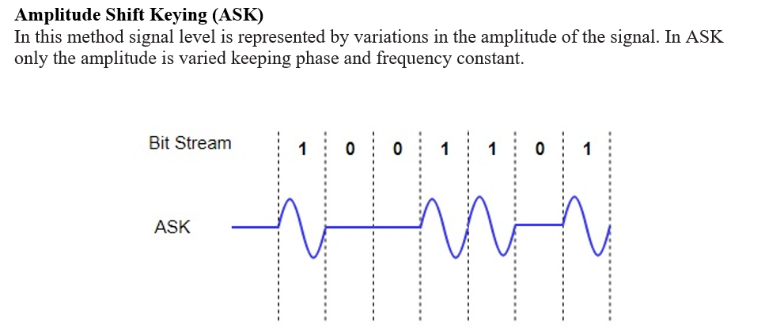

## [Frequency-shift keying](https://www.britannica.com/technology/frequency-shift-keying)

If frequency is the parameter chosen to be a function of the information signal, the modulation method is called frequency-shift keying (FSK). In the simplest form of FSK signaling, digital [data](https://www.britannica.com/dictionary/data) is transmitted using one of two frequencies, whereby one frequency is used to transmit a 1 and the other frequency to transmit a 0. Such a scheme was used in the Bell 103 voiceband [modem](https://www.britannica.com/technology/modem), introduced in 1962, to transmit information at rates up to 300 bits per second over the public switched [telephone](https://www.britannica.com/technology/telephone) network. In the Bell 103 modem, frequencies of 1,080 +/- 100 hertz and 1,750 +/- 100 hertz were used to send binary data in both directions.

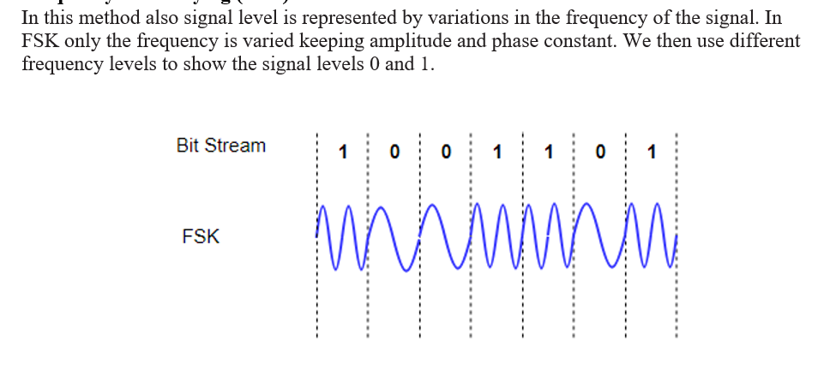

## [Phase-shift keying](https://www.britannica.com/technology/phase-shift-keying)

When phase is the parameter altered by the information signal, the method is called phase-shift keying (PSK). In the simplest form of PSK a single radio frequency carrier is sent with a fixed phase to represent a 0 and with a 180° phase shift—that is, with the opposite polarity—to represent a 1. PSK was employed in the Bell 212 modem, which was introduced about 1980 to [transmit](https://www.britannica.com/dictionary/transmit) information at rates up to 1,200 bits per second over the public switched telephone network.

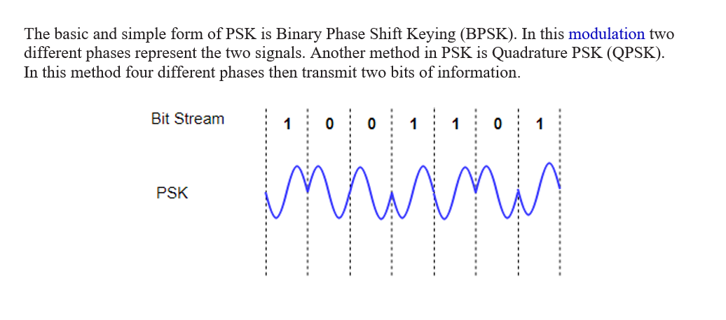

11.Periodic waveforms are those that vary [periodically](https://en.wikipedia.org/wiki/Periodic_function), they repeat regularly at consistent intervals. State 4 Parameters of Periodic Wave Forms

Periodic waveforms are characterized by their repetitive nature, and various parameters describe their properties. Here are four key parameters of periodic waveforms:

1. Amplitude (A):

- Definition: The amplitude of a periodic waveform is the maximum displacement or deviation of the waveform from its equilibrium position (zero point).

- Representation: Denoted as "A," it indicates the strength or intensity of the waveform.

2. Frequency (f) or Period (T):

- Frequency Definition: The frequency of a periodic waveform is the number of cycles (or repetitions) of the waveform that occur in one second. It is measured in Hertz (Hz).

- Period Definition: The period is the reciprocal of frequency, representing the time taken for one complete cycle to occur.

- Representation: Frequency is denoted as "f," and period is denoted as "T," where \(f = \frac{1}{T}\).

3. Phase (ϕ):

- Definition: Phase refers to the relative position of a waveform at a particular point in time compared to a reference waveform.

- Representation: Denoted as "ϕ" (phi), it is measured in degrees or radians and indicates the horizontal shift of the waveform.

4. DC Offset (Direct Current Offset):

- Definition: DC offset represents the average or mean value of a periodic waveform over one complete cycle. It is the vertical shift of the waveform from the zero baseline.

- Representation: Denoted as "DC," it is measured in the same units as the amplitude and is crucial in understanding whether the waveform oscillates around zero or has a nonzero average value.

These parameters are fundamental in describing and analyzing periodic waveforms, providing insights into their shape, intensity, repetition rate, and alignment in time. They are commonly used in various fields, including signal processing, communications, and electrical engineering.

12. Explain how the above RC Filter works

